**Assignment 2 :- Pipeline-Job**

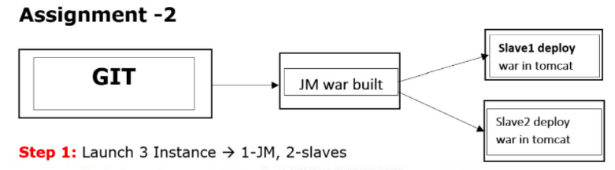

**On Jenkins Master –**

**# clone project of game-of-life from remote-repository**

**# build game-of-life with the help of maven tool**

**# then deploy war file of game-of-life project to slave-1 and slave-2 with the help of scp command**

**On both slave machine –**

**# installing java as 1.8.0 version**

**# download tomcat web server**

**# start tamcat web server**

**Step 2 – Create Node/Agent**

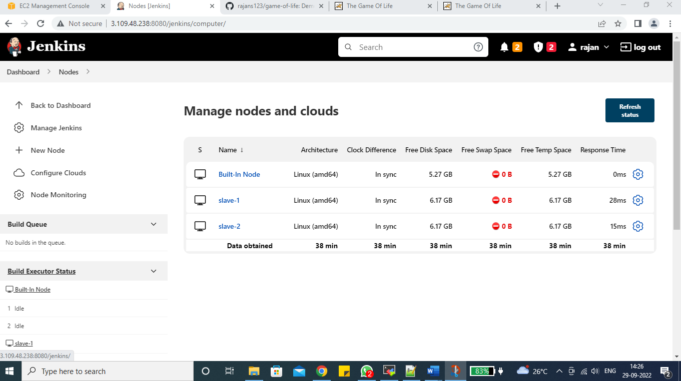

**Step 3 – Create 1 Pipeline-Job**

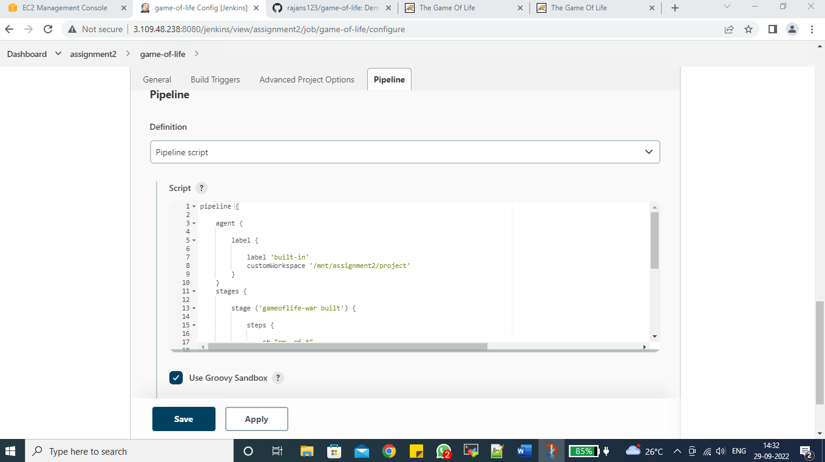

pipeline {

agent {

label {

label 'built-in'

customWorkspace '/mnt/assignment2/project'

}

}

stages {

stage ('gameoflife-war built') {

steps {

sh "rm -rf *"

sh "git clone https://github.com/rajans123/game-of-life.git"

dir ('game-of-life') {

sh "mvn clean install"

}

}

}

stage ('Deploy game-of-life war file on slave-1 & slave-2') {

steps {

sh "scp -i /root/serverkeypair.pem game-of-life/gameoflife-web/target/gameoflife.war ec2-user@172.31.44.54:/mnt/slave-1/web-server/apache-tomcat-9.0.67/webapps/"

sh "scp -i /root/serverkeypair.pem game-of-life/gameoflife-web/target/gameoflife.war ec2-user@172.31.42.109:/mnt/slave-2/web-server/apache-tomcat-9.0.67/webapps/"

}

}

}

}

**Step 4 :- Build Job**

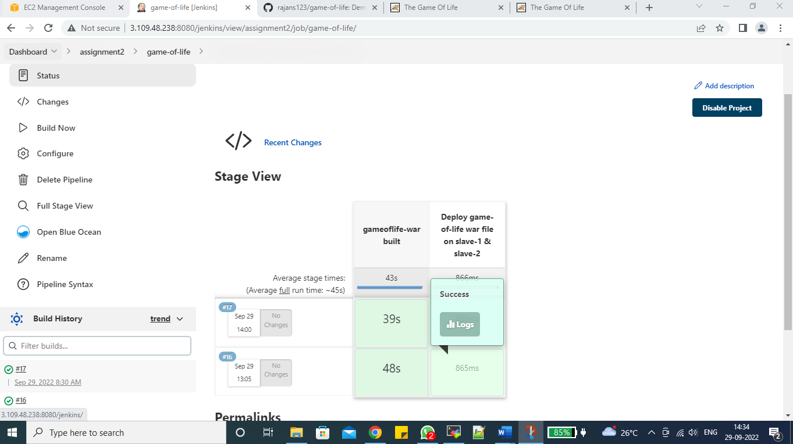

**Step 5 :- Deploy war file of game-of-life on slave-1 & slave-2**

**Slave-1**

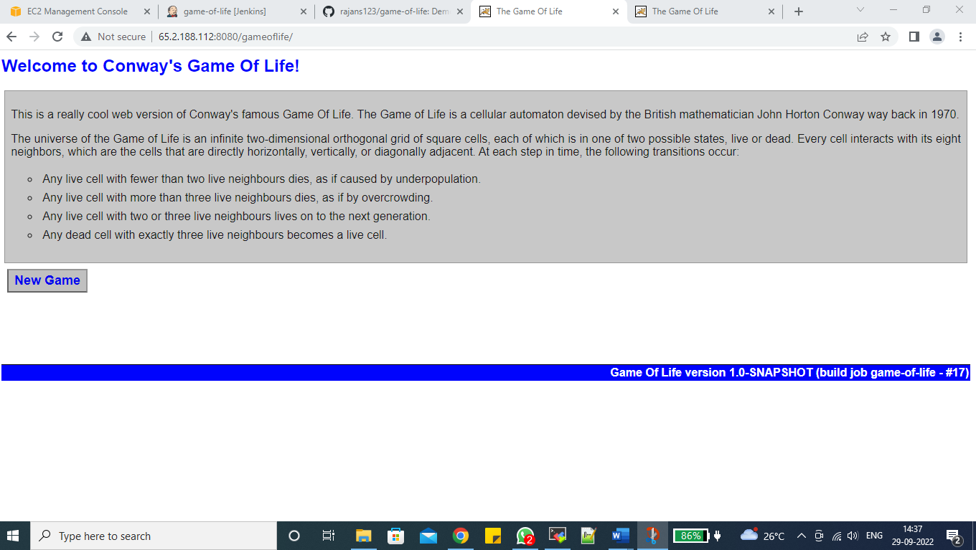

**Slave-2**

